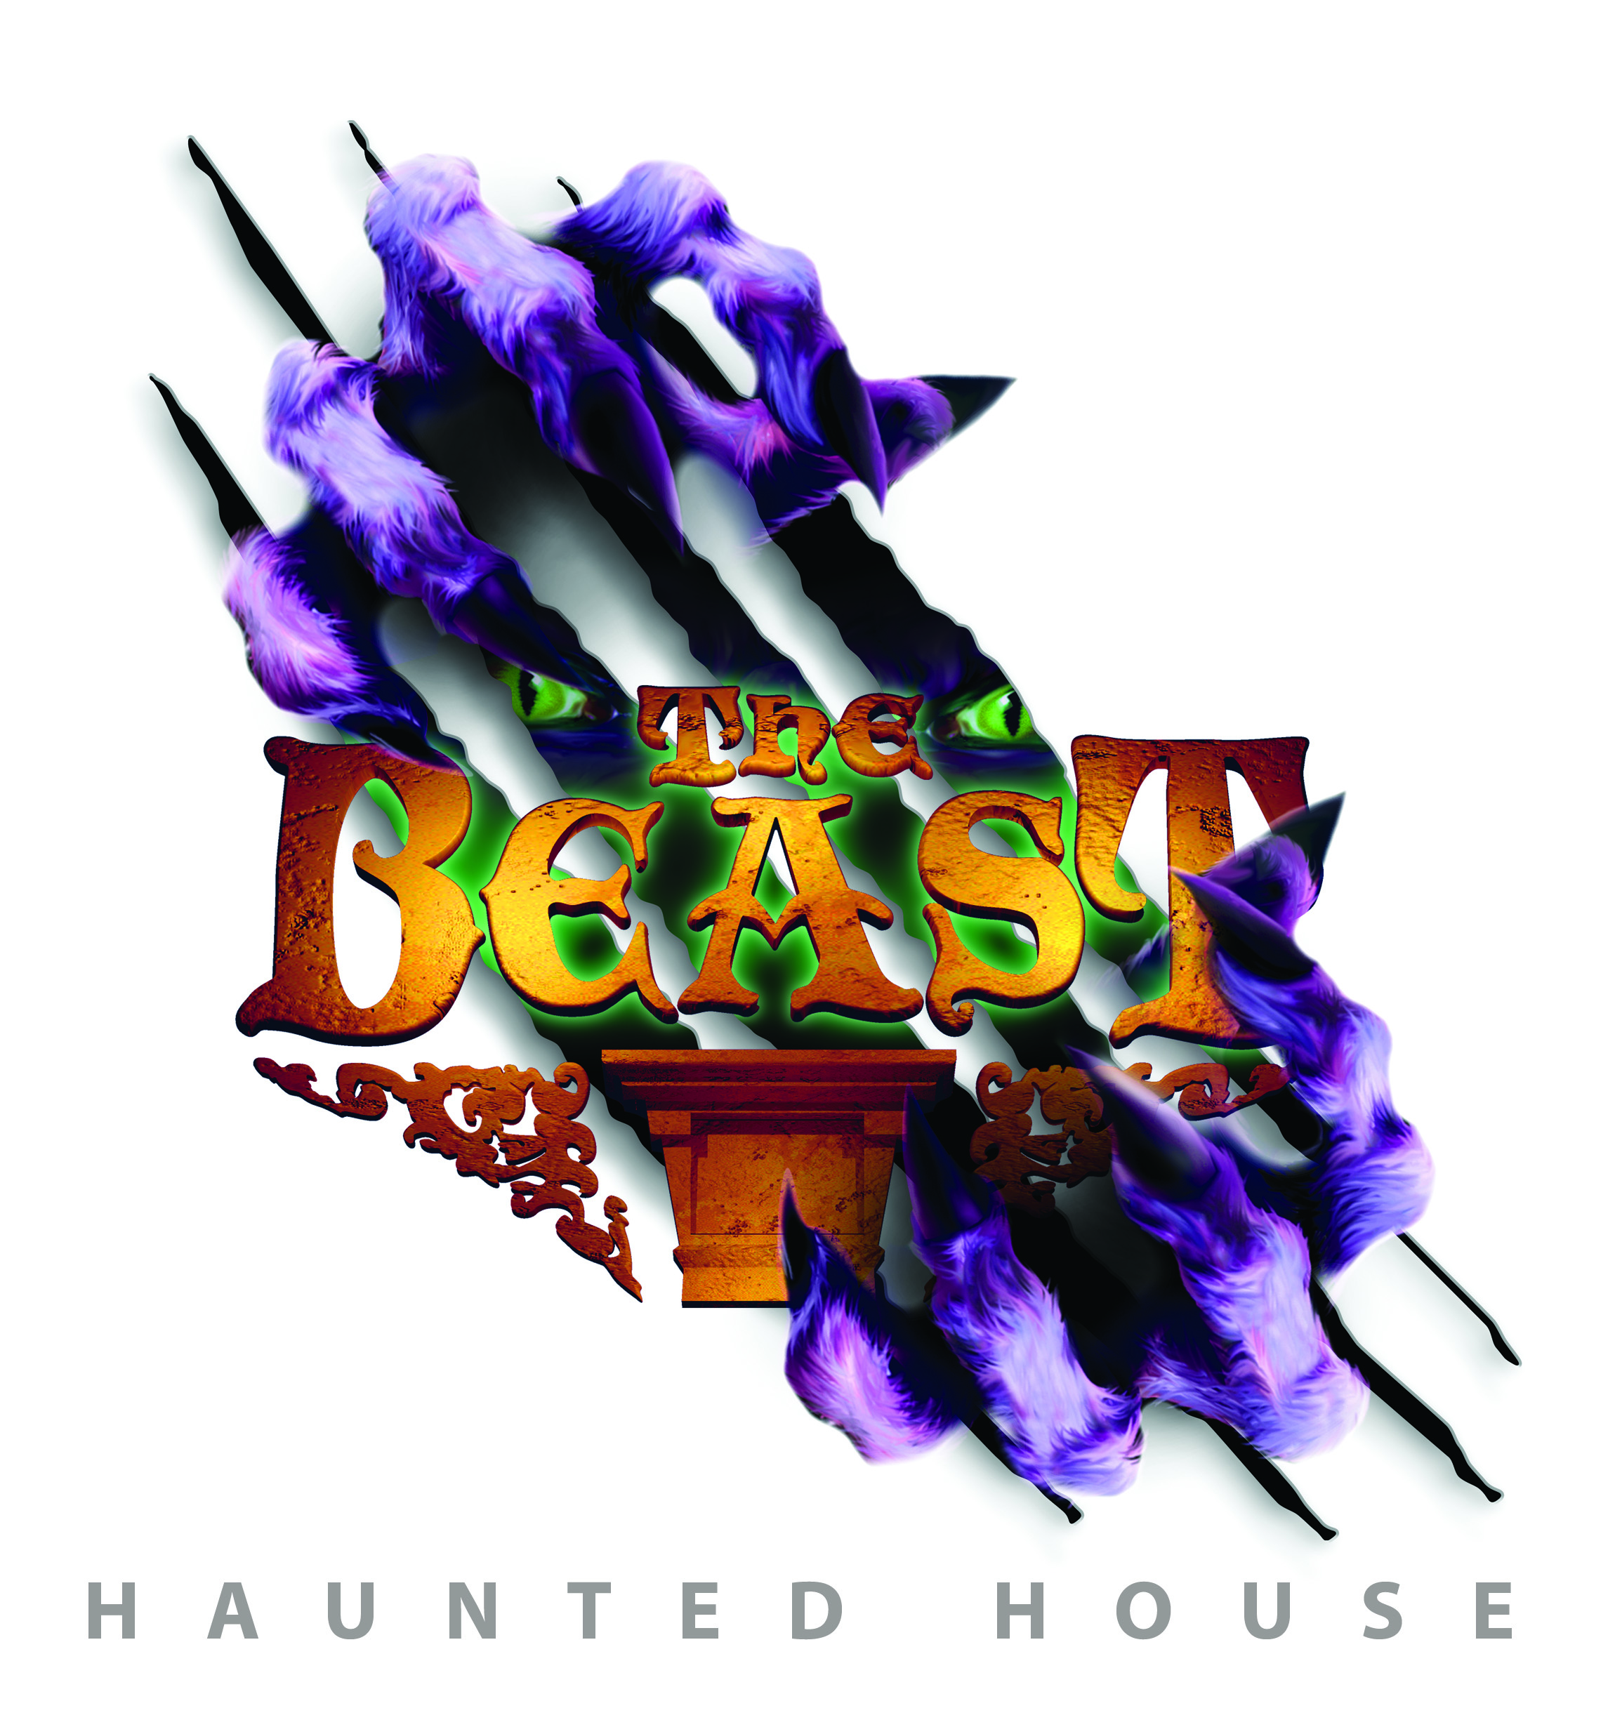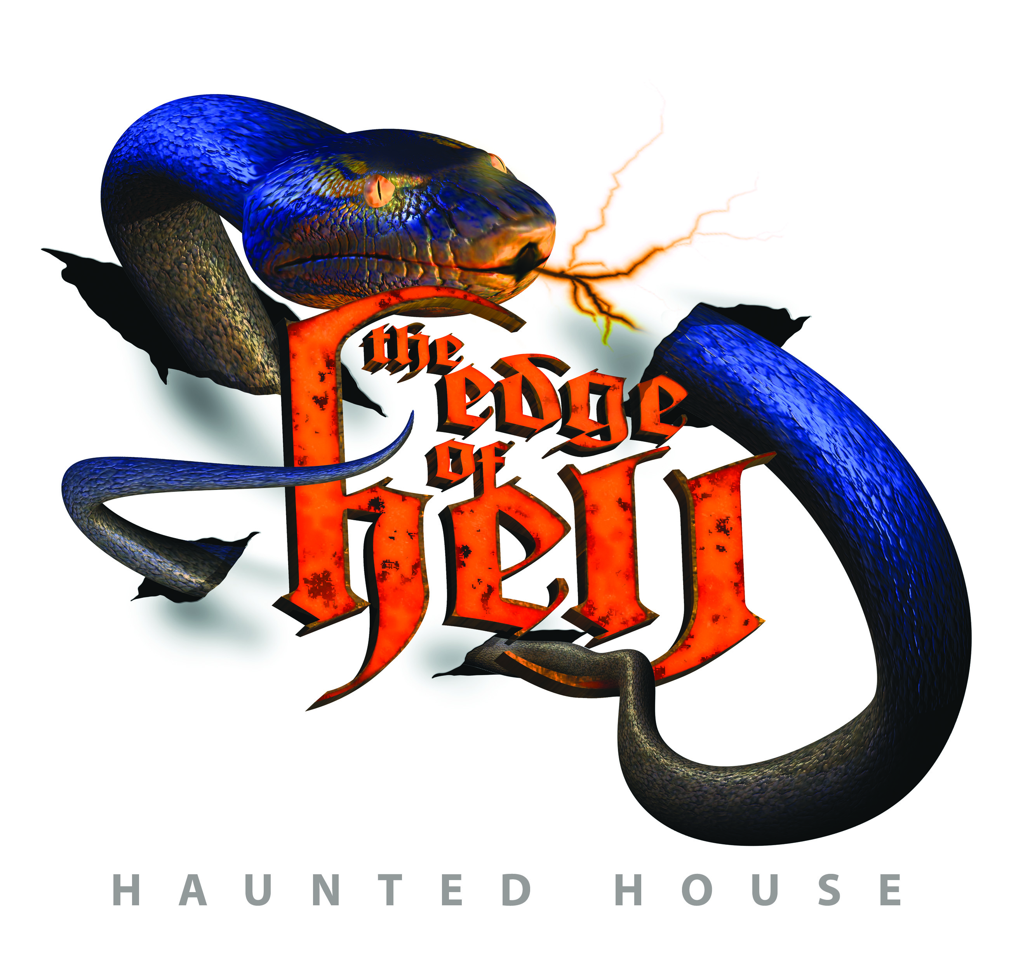

**KANSAS CITY’S WEST BOTTOMS HAUNTED ATTRACTIONS**

1401 W. 13th St., KCMO 64101 [www.fullmoonprod.com](http://www.fullmoonprod.com)

**It is official Kansas City has some of America’s Scariest Attractions**

**Elvira, Travel Channel and More Pick West Bottoms Epic Haunt Attractions among the Best**

October 17, 2013 Kansas City - When it comes to ranking the scariest attractions, Travel Channel and its adviser Elvira, Mistress of the Dark, named Kansas City’s four epic haunted houses in the West Bottoms (Chambers of Poe, Macabre Cinema, Edge of Hell and The Beast) among the 10 scariest haunted attractions in the U.S.

The Travel Channel will broadcast “America’s Scariest Attractions” that features all four West Bottoms haunted houses in October. In addition to this recognition, [Haunt World](http://www.hauntworld.com/featured_article/best_and_scariest_haunted_houses_in_america_oldest_longest_running) named Edge of Hell as the “Best and Scariest Haunted House among the Oldest and Longest Running Attractions” while [HauntedHouseRatings.com](http://hauntedhouseratings.com/top31hauntedhouses.cfm), which ranks votes by visitors, put Edge of Hell and The Beast as tied for 7th place in the nation despite Kansas City being a smaller metropolitan area than all but one of the top ranking haunted houses.

“Kansas City has long been a capital of haunted houses from its height of thirteen- plus haunted houses in the 1980’s and through its transition to fewer yet more sophisticated haunted houses today, said Amber Arnett-Bequeaith “Queen of Screams” operating the West Bottom Haunted Houses. “The survivors must be suited for the ever-discriminating thrill-seeking visitor that witnesses extremes on video games and movies.” Fewer houses are also a fact that seasonal business can be a frightful venture with only a few weeks to recover after bad weather or other untimely events. The West Bottoms, just west of Downtown Kansas City off the 12th Street Bridge, has defied the downturn in haunt offerings and reigns as the Haunted House epicenter with four large haunted houses in this one historic community.

The houses are located in large multi-storied commercial buildings built around 1900 and each has something unique that makes it a must-see horror attraction.

* [Chambers of Poe](http://www.chambersofpoe.com): paranormal activity, ties with Poe’s tales of madness, 4-story window leap and featured in the movie [***Horror Filmed***](http://www.horrorfilmed.com/)
* [Edge of Hell](http://www.edgeofhell.com): sits at 666 feet above sea level, oldest running commercial haunted house in the U.S. est. 1975, focused on phobias, home to the record-breaking reticulated python, 4-story slide
* [The Beast](http://www.kcbeast.com): located on 13th Street, first haunted attraction to utilize an open format and a live alligator and lots of front door entertainment including the Thriller Dancers, Headless Horseman, The Beast and more
* [Macabre Cinema](http://www.macabrecinema.com) Haunted House: staged as a 1930’s haunted movie theater with a collection of actual horror-movie sets and props and a 4 story bat pole that takes people from screen to scream

Despite the short season, the haunted houses stay intact year-round given their size, scope and technology with crews that update and refresh them in the off-season. The haunts include a range of technology from holographic videos, laser trips and animatronics. Live snakes, rats, spider and crocodile also live in the houses year-round but make their appearance during the season to create a scare that is truly a 4-D experience.

Elvira, Mistress of the Dark summarized, “On Kansas City’s west side is one of the most unique haunted venues I’ve ever had the displeasure of visiting. The [KC West Bottoms](http://kcwestbottoms.com/hauntedhouses.htm) area is made up of several late 19th-century buildings that were just made to be haunted houses! This “village of the damned” has 4 -- count ’em 4 -- epic haunts: The Beast, The Chambers of Edgar Allan Poe, Macabre Cinema and the granddaddy of ’em all, The Edge of Hell -- each one is a unique, must-see experience for haunted house afflict-cianados.”

[**Travel Channel’s Best Halloween Attractions 2013**](http://www.travelchannel.com/interests/travels-best/photos/travels-best-halloween-attractions-2013) (slideshow)